Part 1; HINTS FROM SANBORNE:…TO BE USED LATER IN SOLUTION
ADDITIONAL INFORMATION :
- LOWER CASE D IN BURIED
- POSITION 6,22 WHERE O = U….VERTICALLY SAYS TO USE
- 8TH ROW HAS A TICK NEXT TO IT….JIM MENTIONED SOME WHERE ABOUT THE ? BEING LINED UP CORRECTLY WITH POSITION 8,10

- BELOW IS A COPY OF A PHOTO SANBORNE SUBMITTED ONLINE….
- IT IS THE SOLUTION TO K1 AND K2……..

- AT FIRST I COULD NOT SEE WHAT THE CLUES WHERE UNTIL I LOOKED VERY CLOSELY….
- YOU WILL NOTICE THAT THERE ARE TWO LETTER E………IN LOWER CASE …NOT FOUND ANY WHERE ELSE……SO THESE ARE UNIQUE…
- POSITIONS (1,8)
- AND (8,26)……
- THESE DO NOT REALLY MEAN ANY THING UNTIL YOU SPOT WHY THEY ARE IMPORTANT…..
- IN THE FIRST SMALL LETTER E POSITION(1,8) THE VERTICAL LETTERS ARE S E L..
- IN THE SECOND SMALL LETTER E POSITION (8,26) THE VERTICAL LETTERS ARE …….E C Q
- THEN LOOKING AT THE ENTIRE SOLUTION…… I NOTICED THAT THES LETTER SEQUENCES ARE REVERSED AND HORIZIONTAL…..
- SO VERTICAL S E L BECOMES HORIZIONTAL AND REVERSED….. L E S BEGINNING AT POSITION 1,12, 1,13 AND 1,14
- SO VERTICAL E C Q BECOMES HORIZIONTAL AND REVERSED T0 Q C E 6,20 6,21 6,22
- in addition l if you have noticed that the first SEL letters are aligned with the plaintext solution
- and the QCE is aligned with the code .

LOOK AT THE ARROWS THAT ARE ON THE PAGE - ROW 1 CODE ROW 2 CODE
LOOK AT THE VERY FAINT DOTS ABOVE SOME LETTERS
PALIMPCEST IS SPELT INCORRECTLY
SOME LETTERS ARE DARKER OR ENHANSED MORE THAT OTHERS
THERE ARE TICK MARKS BELOW SOME COLUMNS
WE ONLY RECEIVED THE FIRST 8 ROWS……
VERTICAL MARK ABOVE PPLAINTEXT = INVISIABLE
NLD = LAST COLUMN OF K1 SOLUTIION IS NOT FOLLOWING SEQUENCE AND ATTACHED TO ROW 2..WHY
ROW 5 HAS CSI ATTACHED TO LEFT HAND SIDE OF MATRIX..

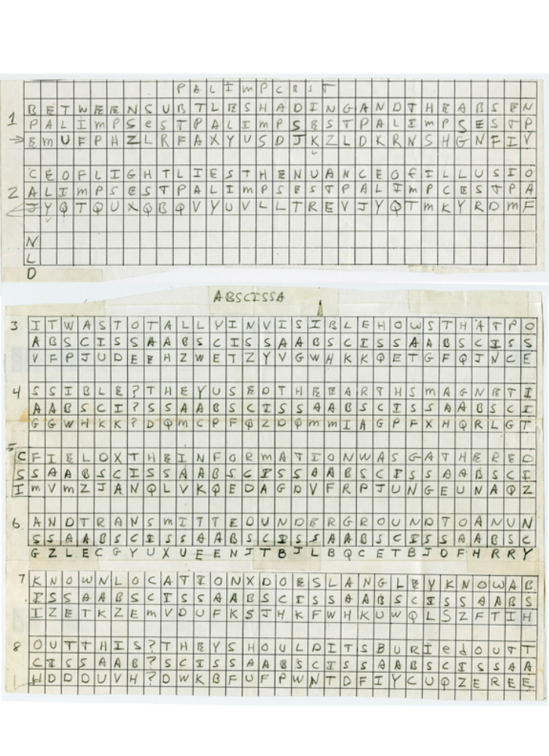

C S I = shortened for Crime Scene Investigation= look for forensic material (5,32)

CLUES I FOUND IN SANBORN SOLOUTION TO K1 AND K2- LOWER CASE E
LETTER EXCHANGES = ARE CHANGED CELL COLOUR FOR EASIER IDENTIFICATION
Q=L 2,26 O=U 6,22
INTERSTING CO ORDINATE POSITIONS..THERE ARE A REVERSE OF EACH OTHER

 |  | 1 | 2 | 3 | 4 | 5 | 6 | 7 | 8 | 9 | 10 | 11 | 12 | 13 | 14 | 15 | 16 | 17 | 18 | 19 | 20 | 21 | 22 | 23 | 24 | 25 | 26 | 27 | 28 | 29 | 30 | 31 | 32
 |  |  |  |  |  |  |  |  |  |  | P | A | L | I | M | P | C | E | S | T |  | 3 | 1 | 2
1 |  | B | E | T | W | E | E | N | S | U | B | T | L | E | S | H | A | D | I | N | G | A | N | D | T | H | E | A | B | S | E | N
1 |  | P | A | L | I | M | P | S | E | S | T | P | A | L | I | M | P | S | E | S | T | P | A | L | I | M | P | S | E | S | T | P
1 |  | E | M | U | F | P | H | Z | L | R | F | A | X | Y | U | S | D | J | K | Z | L | D | K | R | N | S | H | G | N | F | I | V
2 |  | C | E | O | F | L | I | G | H | T | L | I | E | S | T | H | E | N | A | U | N | C | E | O | F | I | Q | L | U | S | I | O | N
2 |  | A | L | I | M | P | S | E | S | T | P | A | L | I | M | P | S | E | S | T | P | A | L | I | M | P | C | E | S | T | P | A | L
2 |  | J | Y | Q | T | Q | U | X | Q | B | Q | V | Y | U | V | L | L | T | R | E | V | J | Y | Q | T | M | K | Y | R | D | M | F | D
 |  |  |  |  |  |  |  |  |  |  |  |  | A | B | S | C | I | S | S | A |  | 2 | 1 | 3
3 |  | I | T | W | A | S | T | O | T | A | L | L | Y | I | N | V | I | S | I | B | L | E | H | O | W | S | T | H | A | T | P | O
3 |  | A | B | S | C | I | S | S | A | A | B | S | C | I | S | S | A | A | B | S | C | I | S | S | A | A | B | S | C | I | S | S
3 |  | V | F | P | J | U | D | E | E | H | Z | W | E | T | Z | Y | V | G | W | H | K | K | Q | E | T | G | F | Q | J | N | C | E
4 |  | S | S | I | B | L | E | ? | T | H | E | Y | U | S | E | D | T | H | E | E | A | R | T | H | S | M | A | G | N | E | T | I
4 |  | A | A | B | S | C | I | ? | S | S | A | A | B | S | C | I | S | S | A | A | B | S | C | I | S | S | A | A | B | S | C | I
4 |  | G | G | W | H | K | K | ? | D | Q | M | C | P | F | Q | Z | D | Q | M | M | I | A | G | P | F | X | H | Q | R | L | G | T
5 | C | F | I | E | L | D | X | T | H | E | I | N | F | O | R | M | A | T | I | O | N | W | A | S | G | A | T | H | E | R | E | D
5 | S | S | A | A | B | S | C | I | S | S | A | A | B | S | C | I | S | S | A | A | B | S | C | I | S | S | A | A | B | S | C | I
5 | I | M | V | M | Z | J | A | N | Q | L | V | K | Q | E | D | A | G | D | V | F | R | P | J | U | N | G | E | U | N | A | Q | Z
6 |  | A | N | D | T | R | A | N | S | M | I | T | T | E | D | U | N | D | E | R | G | R | O | U | N | D | T | O | A | N | U | N
6 |  | S | S | A | A | B | S | C | I | S | S | A | A | B | S | C | I | S | S | A | A | B | S | C | I | S | S | A | A | B | S | C
6 |  | G | Z | L | E | C | G | Y | U | X | U | E | E | N | J | T | B | J | L | B | Q | C | E | T | B | J | O | F | H | R | R | Y
7 |  | K | N | O | W | N | L | O | C | A | T | I | O | N | X | D | O | E | S | L | A | N | G | L | E | Y | K | N | O | W | A | B
7 |  | I | S | S | A | A | B | S | C | I | S | S | A | A | B | S | C | I | S | S | A | A | B | S | C | I | S | S | A | A | B | S
7 |  | I | Z | E | T | K | Z | E | M | V | D | U | F | K | S | J | H | K | F | W | H | K | U | W | Q | L | S | Z | F | T | I | H
8 |  | O | U | T | T | H | I | S | ? | T | H | E | Y | S | H | O | U | L | D | I | T | S | B | U | R | I | E | D | O | U | T | T
8 |  | C | I | S | S | A | A | B | ? | S | C | I | S | S | A | A | B | S | C | I | S | S | A | A | B | S | C | I | S | S | A | A
8 |  | H | D | D | D | U | V | H | ? | D | W | K | B | F | U | F | P | W | N | T | D | F | I | Y | C | U | Q | Z | E | R | E | E
9 |  | H | E | R | E | S | O | M | E | W | H | E | R | E | X | W | H | O | K | N | O | W | S | T | H | E | E | X | A | C | T | L
 |  | B | S | C | I | S | S | A | A | B | S | C | I | S | S | A | A | B | S | C | I | S | S | A | A | B | S | C | I | S | S | A
 |  | V | L | D | K | F | E | Z | M | O | Q | Q | J | L | T | T | U | G | S | Y | Q | P | F | E | U | N | L | A | V | I | D | X
10 |  | O | C | A | T | I | O | N | ? | O | N | L | Y | W | W | T | H | I | S | W | A | S | H | I | S | L | A | S | T | M | E | S
 |  | A | B | S | C | I | S | S | ? | A | A | B | S | C | I | S | S | A | A | B | S | C | I | S | S | A | A | B | S | C | I | S
 |  | F | L | G | G | T | E | Z | ? | F | K | Z | B | S | F | D | Q | V | G | O | G | I | P | U | F | X | H | H | D | R | K | F
11 |  | S | A | G | E | X | T | H | I | R | T | Y | E | I | G | H | T | D | E | G | R | E | E | S | F | I | F | T | Y | S | E | V
 |  | S | A | A | B | S | C | I | S | S | A | A | B | S | C | I | S | S | A | A | B | S | C | I | S | S | A | A | B | S | C | I
 |  | F | H | Q | N | T | G | P | U | A | E | C | N | U | V | P | D | J | M | Q | C | L | Q | U | M | U | N | E | D | F | Q | E
12 |  | E | N | M | I | N | U | T | E | S | S | I | X | P | O | I | N | T | F | I | V | E | S | E | C | O | N | D | S | N | O | R
 |  | S | S | A | A | B | S | C | I | S | S | A | A | B | S | C | I | S | S | A | A | B | S | C | I | S | S | A | A | B | S | C
 |  | L | Z | Z | V | R | R | G | K | F | F | V | O | E | E | X | B | D | M | V | P | N | F | Q | X | E | Z | L | G | R | E | D
13 |  | T | H | S | E | V | E | N | T | Y | S | E | V | E | N | D | E | G | R | E | E | S | E | I | G | H | T | M | I | N | U | T
 |  | I | S | S | A | A | B | S | C | I | S | S | A | A | B | S | C | I | S | S | A | A | B | S | C | I | S | S | A | A | B | S
 |  | N | Q | F | M | P | N | Z | G | L | F | L | P | M | R | J | Q | Y | A | L | M | G | N | U | V | P | D | X | V | K | P | D
14 |  | E | S | F | O | R | T | Y | F | O | U | R | S | E | C | O | N | D | S | W | E | S | T | X | L | A | Y | E | R | T | W | O
 |  | C | I | S | S | A | A | B | S | C | I | S | S | A | A | B | S | C | I | S | S | A | A | B | S | C | I | S | S | A | A | B
 |  | Q | U | M | E | B | E | D | M | H | D | A | F | M | J | G | Z | N | U | P | L | G | E | W | J | L | L | A | E | T | G

